**COMP3217 Security of Cyber-Physical Systems 20/21**

**Coursework 2: Detection of Manipulated Pricing in Smart**

**Energy CPS Scheduling**

Module: COMP3217

Student ID: 31122949

Shantanu Awasthi (sa11g19)

Monday 23rd May, 2022

Contents

1. Introduction 3

1.1. Task 3

1.2. Linear Programming 3

1.3. Linear Discriminant Analysis (LDA) 3

2. Implementation 4

2.1. Git Repository 4

2.2. Makefile 4

2.3. Label Prediction 4

2.4. LDA 5

2.5. Linear Programming (LP) 5

2.6. Graph Plotting 5

3. Results 7

4. References 7

5. Appendices 8

5.1. Readme 8

5.2. Makefile 8

5.3. Full Results 8

# Introduction

The purpose of this coursework is to understand energy scheduling for a smart home, cyber-physical system (CPS) based on Linear Programming, as well as the interdependence between the pricing information and energy load scheduling.

## Task

A small community of 5 users, each has 10 smart home appliances. These users will have varying energy consumptions throughout the day (any period of 24 hours). Naturally, appliance usage will be far greater during the day while the users are awake and often have peak usage at the same time(s) as other users. To keep up with this energy demand, energy providers set higher prices during these peak times to discourage users from using their appliances, resulting in a lower load that needs to be managed by the providers. A smart home scheduling system can be used to provide the user with a schedule of when to use their appliances throughout the day, theoretically lowering the cost to the user. For example, if there are two free time-incremented slots before a task is to be done but the second time slot would be cheaper to do a task in, the system would advise the user to conduct the task in the second slot.

Such a system can be computed via linear programming to decide which appliance to use and when. In order to build an effective system, a set of data, outlining each of the tasks performed by each of the 5 users, has been provided and used. There are, however, some abnormal values for the pricing of energy costs over this period which are vital to be detected by the scheduling system and adjust accordingly.

## Linear Programming

Linear Programming is an optimisation technique that uses linear functions to demonstrate complex relationships and then to find an optimal solution. Examples of linear programming in the real world include profit maximisation and cost minimisation. An example of a linear equation is as such:

*Find the minimum and maximum value of the objective function: $z=4x+5y$* (1)

*Subject to: $x≥0;y≥0;x+y≤6$*

In equation 1, “z” is the objective function that defines the variable/quantity to be optimised. The constraints are defined as linear inequalities with “ $x,y≥0$” being the non-negativity constraints, and “x, y” being the decision variables. The aim of a linear program is to calculate the optimum solution to a problem with the given constraints.

## Linear Discriminant Analysis (LDA)

Linear Discriminant Analysis is a dimensionality reduction technique that is commonly used for supervised classification problems, such as image recognition and predictive marketing analysis systems. An example where LDA can be used is if there are two classes (these can have multiple features) that need to be efficiently separated. If only a single feature is being used for classification, it may result in something called “overlapping” of data points. In order to overcome this issue, the number of features should be increased.

LDA focuses on projecting the features from a higher dimension space to lower dimensions. This is usually achieved in three steps:

* Calculate the separability between classes, called the *between-class variance*, mathematically defined as:
$$S_{b}=\sum_{i=1}^{g}{N_{i}({\overline{x}}_{i}-\overline{x}){({\overline{x}}_{i}-\overline{x})}^{T}}$$

* The next step is to calculate the distance between the mean and the sample of each class, called the *within-class variance*, mathematically defined as:
$$S_{v}=\sum_{i=1}^{g}{\left(N_{i}-1\right)S_{i}=}\sum_{i=1}^{g}{\sum_{j=1}^{N_{i}}{(x_{ij}-{\overline{x}}_{i}){(x_{ij}-{\overline{x}}_{i})}^{T}}}$$

* Finally, construct a lower-dimensional space which maximises the between-class variance and minimises the within-class variance. This is projected on the lower dimension, P, and is called Fisher’s Criterion:

$$P_{lda}=\arg{\max{p}}\frac{\left|P^{T}S_{b}P\right|}{\left|P^{T}S_{w}P\right|}$$

# Implementation

## Git Repository

The implementation of this project used a GitHub repository for back-ups, storage, and access between physical and virtual machines. This repository can be viewed from here:

<https://git.soton.ac.uk/sa11g19/COMP3217-Coursework-2>

## Makefile

To run this project, a Makefile was used (Appendix ). There are three commands that can be used to run the various aspects of this project:

* “make setup” – runs a “requirements.txt” file which installs the required modules to run the various file
* “make run” – runs “classify.py” which classifies all the data pieces as normal (0) or abnormal (1)
* “make print” – Prints the predictions (0 or 1) in an output file "TestingResults.txt".
* “make compare” – Runs different classification methods and outputs the accuracy of each model.
* “make schedule” – Plots the schedules for each of the normal datasets in the folder called "plots".

This project can be cloned or downloaded from the git link mentioned in 2.1 and the above functions can be run in the terminal.

## Label Prediction

|  |  |  |  |
| --- | --- | --- | --- |
| **Classification Type** | **Accuracy (%)** | **Accuracy on 20% (%)** | **Time Taken (s)** |
| KNN | 87.5 | 80.3 | 0.329 |
| Decision Tree | 95.6 | 78.0 | 0.137 |
| Logistic Regression | 94.1 | 93.7 | 0.025 |
| Support Vector Machine (SVM) | 98.5 | 96.4 | 2.355 |
| Linear Discriminant Analysis (LDA) | 94.0 | 94.0 | 0.048 |
| Gaussian Naïve Bayes (GNB) | 94.3 | 94.0 | 0.000 |
| Multi-Layer Perceptron (MLP) | 96.7 | 84.7 | 7.085 |

In order to predict the labels for the training data provided, I implemented the Linear Discriminant Analysis (LDA) classifier using python. To decide the best classifier to use for this task, I compared the accuracies of different algorithmic models, with their results shown below in Table 1. Table 1 also shows the accuracy of 20% of the training data as a form of validation.

*Table 1: Comparing accuracies of various algorithms*

Both forms of accuracies are compared against the time taken to run the classification. Using the results above, I decided to use LDA due simply to the ease of implementation, compared with GNB which also provides the same degree of accuracy and performs the task slightly quicker.

## LDA

LDA has been implemented using the scikit library, available for python. Figure 1 provides a snippet of the implementation.

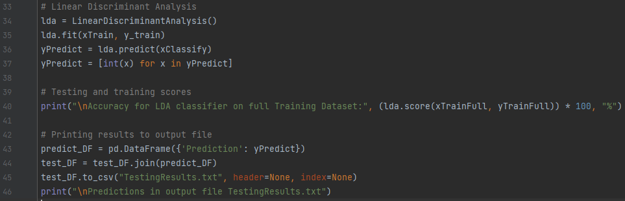

Figure 1: LDA code snippet

## Linear Programming (LP)

To implement the LP solution for this coursework, the “pulp” library, from python, was used. Pulp is an LP modeler which is written in python and can generate LP files to solve linear problems. The code snippet for this is shown in Figure 2.

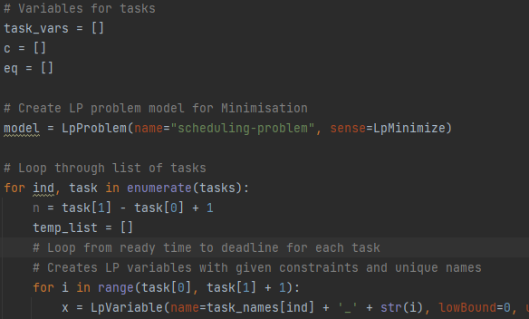

Figure 2: LP model code snippet

## Graph Plotting

To display the pricing schedule for the normal and abnormal usage, the “matplotlib” library was used to plot a grouped bar chart for each of the 5 users throughout the day (24-hour period). The code snippet is shown below in Figure 3.

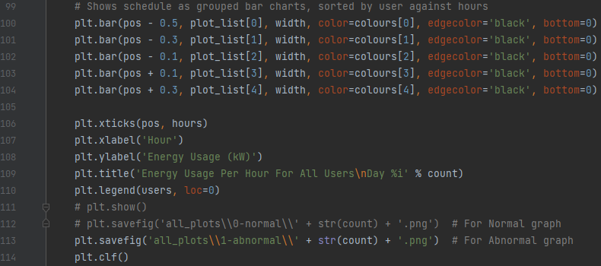

Figure 3: Code snippet for graph plotting

# Results

The results were displayed as the grouped bar charts, shown in Figure . The left graph in Figure shows the predicted abnormal usage, and the right graph shows the predicted normal usage. The complete collection of these plots can be found on GitHub under the “all_plots” folder.

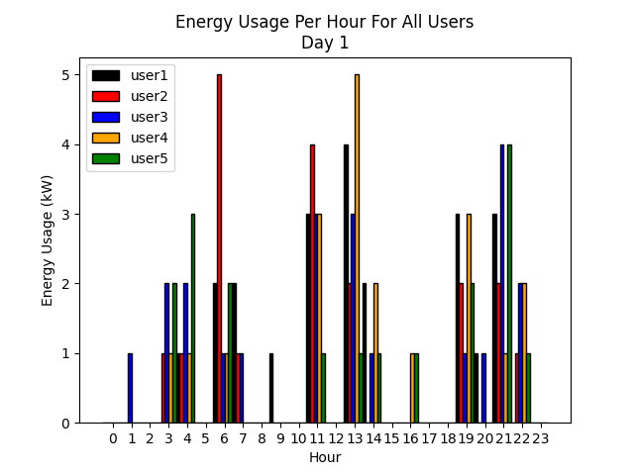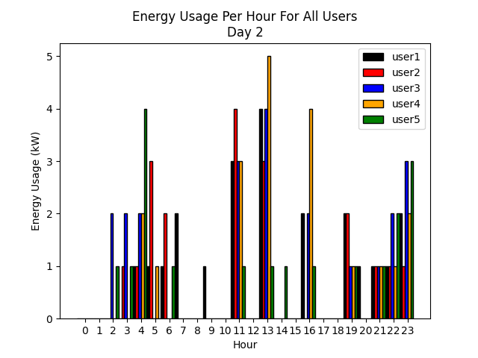

Figure 4: Predicted Abnormal and Normal Usage, respectively

# References

[1] *4 Types of Classification Tasks in Machine Learning*. (n.d.). Accessed May 18, 2022, from https://machinelearningmastery.com/types-of-classification-in-machine-learning/

[2] *ML | Linear Discriminant Analysis - GeeksforGeeks*. (n.d.). Accessed May 18, 2022, from https://www.geeksforgeeks.org/ml-linear-discriminant-analysis/

# Appendices

## Readme

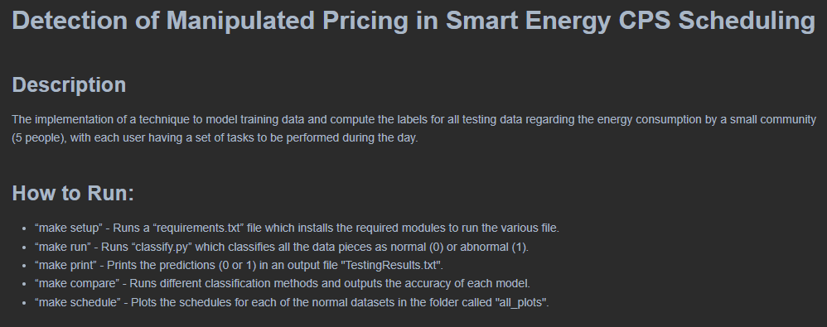

## Makefile

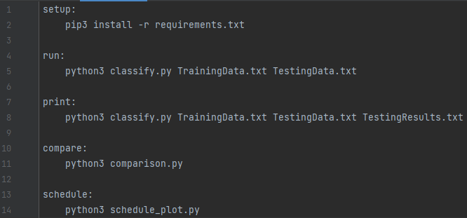

## Full Results

Refer to “TestingResults.txt”

4.51285340120281,3.43658107523701,3.68255559134804,3.06271757467767,3.45627812546856,4.02803853654439,3.53047024505285,4.29234009190491,5.01899399964376,4.7831896810001,5.39649373091393,3.62164525353888,6.52511405066837,4.34263631482957,5.85722269007359,6.38160238785678,6.11551929701169,6.29475554382194,6.5131445728803,5.25018950601471,5.913804588632,5.12382685690879,5.62943812228955,5.75354475562452,1

4.03820071716011,3.87422093478939,3.12074256074567,3.26164272347754,2.99071686468326,3.78911484916221,3.93584930284598,4.3918235403584,5.35657491584115,5.27440760790772,5.43940289782185,3.82322112434152,6.00344874896901,4.26308831924117,5.82226909964812,6.20644392433416,5.63174696943247,6.63198305899198,6.59344070270602,5.6437680611657,5.93098606117518,5.4217725742733,5.15051876347091,5.12666115880164,0

4.34361935073469,3.25460483051198,3.13028996429568,3.58364653748905,3.02188878387657,3.95300965746551,4.37910228721382,4.43252466608761,5.47811452985101,4.91498570952185,5.09286137359995,3.65202287774894,6.10748896148895,4.64771930953131,5.28437432204782,6.25225102067738,5.77187605993219,6.02301512335747,6.34011783233406,5.39861255438499,5.17621512649868,5.19333185997638,5.5436607903042,5.14826158019733,0

4.21591587881466,3.31080273072025,3.14480757688751,2.82613148545632,2.97904186900045,3.26411760938394,3.64000892434486,4.33290153855674,5.84245312231793,4.56010803699581,5.06548122054094,3.79245256200136,6.19025006003543,4.62270054822735,5.43725430125662,6.42027131256629,6.01426854133015,6.44723990968787,6.78865242053508,5.72137282801631,5.92339358076645,4.98904270511116,5.79721826748552,5.72337487524436,0

4.60766218816615,3.68897114494949,3.80465317995334,2.88243442279745,3.24736215992841,3.39361523937722,3.72086091258205,3.60027343461571,5.53635011224041,4.65351191369647,5.82005477994048,3.86920329817874,6.32451882850277,4.7420371412062,5.40238194490625,5.78492925309961,6.34096845204416,6.64960313543513,6.72080835191463,5.39202053311001,5.13029647968886,5.53280473024764,6.02896168236726,5.49641827749868,1

4.55019045720233,3.60551693533273,3.04092795249486,3.65342290669847,3.34423400070498,3.1630243970635,3.83425525963864,4.11381296415122,5.61066458689976,4.77474062053618,5.6526758435808,3.7617791679847,5.82696521322066,4.92349984258871,5.42736701362619,6.54904951238883,6.13122237037533,5.90834968696809,6.52981939588579,5.09663362786039,5.29499820849339,5.19955997379004,5.3173790727871,5.74339900671985,1

3.97226863349362,3.90549096313721,3.65479334770164,3.54703472949675,3.49346184002345,3.66120371586509,4.23721838545672,3.62596291618578,5.21879797679872,4.80135883131913,4.94994391503005,3.61700369707877,5.81101925007463,4.40289586830003,5.3858227240796,6.0980066658206,5.71017398328097,6.63795343158749,6.88867956716395,5.46801445662244,5.90905410633094,5.27569048633904,5.4551353335071,5.09837396254507,0

4.37262715794462,4.0628413087098,3.68451178364081,3.45691169177382,3.40237437467646,3.32094219427881,3.86999186284685,4.20636311522058,5.57398754306493,4.80019187627004,5.11288453326342,3.52462872825933,6.5945838227744,4.48608901774641,5.39298743877051,6.11184805486147,5.41970288296053,6.59559584811664,6.50636482703784,5.96745948913791,5.46663546580134,5.31061806778933,5.29273776731031,5.91240651330332,1

4.42134726470853,3.68375776122237,3.92320684637861,3.07072971455386,3.40595819883718,3.37506203708276,4.12545733376753,3.59536372648399,5.13690163626308,4.58661517473723,5.26733445077691,3.84707398866641,5.85928754393797,4.89568129894184,5.76543726354101,6.48367519103213,5.56485888588049,6.58058733293443,6.28484346865736,5.34122791467953,5.93804295345015,5.03538266892905,5.40466648400341,5.0075062515716,1

3.87045465437089,4.04627612765736,3.56552262172359,3.19617407182138,2.73242165405645,3.22208835303722,4.13203306134217,4.09550494823892,4.99840271895613,4.85042197924277,5.90776431571379,3.8996195749243,6.22109098800931,4.5747017217209,5.55554351996514,5.65989108292358,5.86742916055483,6.7127089611432,6.04757683279362,5.52462552003853,5.33147728172641,5.25900615801642,5.67192815289813,5.56064524266197,0

4.53899927821287,4.06058865176699,3.50352030750121,2.76512796866754,3.44191394006455,3.47861514062683,4.38377104201957,4.21683978471297,5.44690617393764,4.78208138639832,5.39733578917298,4.15646950757921,6.20616024865905,4.03915182806392,5.21458457615034,6.63379295026237,6.23866140216676,6.13237324651174,6.19649787721053,5.29129743189266,5.27655389356068,5.75050713311583,5.66782783495676,5.33783557780563,1

4.45515677385729,3.71184221690223,3.94811414016483,2.94852074457607,3.43095961896894,3.24240063364423,3.66314851982762,4.36854183439755,4.96389556076244,5.30520564903643,5.05477989271383,4.11850438525215,5.74404139835065,4.32471722739661,5.68236175175338,5.7296513115893,6.23915284710504,6.62023153038528,6.35413277262756,5.32561225413445,5.43260510472612,5.47009441490192,5.18885417747686,5.11068868039725,0

4.68163649282256,3.35941386583183,3.32427010274222,3.47488834944857,3.66229909806977,3.23576560529748,3.57135646700725,3.6540916986923,5.01082579597824,4.81437261931057,5.50655696179536,4.30532398455938,5.84725104971565,4.31038989729462,4.95487036867434,6.33427204049809,5.86110680161772,5.88678624909748,6.32435795812129,5.86814685315291,5.47355172862004,5.5935682483188,5.89200502972277,4.96980910226514,1

4.65193402025957,4.01407008783319,3.16014574146774,3.64104941688926,3.17058993096409,3.81244894714306,3.67222271846633,3.75052143878534,5.72551597218911,4.60597570623477,5.76286290661501,4.08233138297609,5.92692763082882,4.46051315795751,5.64419756999058,5.92757345165623,6.15551782929222,5.85229244823467,6.55825881582304,5.2945699018238,5.18213130684752,5.4321246271673,5.36551292131558,5.11109195573192,0

4.30949944162331,3.363291449428,3.57201785724151,3.11129073510299,3.34227119914474,3.18162079549766,3.78151426296406,4.55301114728085,5.62932251435296,5.00679372849903,5.30278559424473,3.67790944936253,6.62969575715948,4.95550319858352,5.72236766010167,5.72934658589042,5.518203638263,6.76862003480998,6.84307669843502,5.56290030653113,5.32107213437986,4.92480494515314,5.37493868921331,5.08638638126588,0

4.21761075131476,3.52480797621369,3.25928813119766,3.21341365233353,3.005477626076,4.09316373943752,4.14162461139402,3.73405060989698,5.82650205473827,5.0384532544181,5.87340315654914,4.27928250909636,6.1667752484635,4.32707974294564,4.99974821869094,6.5887521382915,5.65531439961598,6.81046507922116,6.78229254415029,5.96641193547393,5.47445557358605,5.54465447505894,5.4102935432139,4.98423601409188,1

3.76516886161779,3.42843890222124,3.39389500395787,2.88762664056472,3.48251036425409,4.02813822962195,3.53367152719629,4.4956929277954,5.69771445030462,5.01423108263539,5.88236803148976,4.24488891703295,6.02534456390865,4.33431837204348,5.45940163553246,6.14372495664315,5.83077866069565,5.99749613822701,6.16603389575716,5.15899739903034,5.76759541482246,4.78865370798787,5.84752323362847,5.85003253256557,1

3.74832170065198,3.52263951381611,3.82490010593778,3.7292813159959,3.51259932760719,3.20631736021844,3.88105264353095,4.40760577254821,5.27081875554927,4.95461126850178,5.11828694137448,3.68607254376929,6.03481384967507,4.16978087690102,5.67001619895027,6.38198809458221,5.45645431168111,6.54755212920901,6.29481625358662,5.48244901478119,5.56501508603049,5.71592868012023,5.93428214835567,5.19025364195251,1

3.75267687008403,3.34817210304806,3.77518131959164,3.18633693088543,3.51893900213272,3.23091888701609,3.80439804722484,4.15113786639136,5.10695160637244,4.74002297037331,5.27659808020211,4.04781415506191,6.15898041469568,4.59539717063176,5.87413479368636,5.79268295623399,5.48859205119102,6.59080911853294,6.1123845143503,5.52835571347566,5.15056000969758,4.84073788949785,6.05679210902429,5.78778752944181,1

4.53096378988424,3.56482804081621,3.12531548087506,2.97474957758993,3.36401544849232,3.45794173553911,4.38163915869592,4.03064512811367,5.74624463163691,4.80963001774659,5.0980064463748,3.63128501497166,6.11046462231349,4.55118014589244,5.39617523121657,6.07215716443554,5.53502833873749,6.73122007880936,6.59586489227292,5.131004913845,5.77373446514039,5.60304618202245,5.45158769950418,5.77117226402186,1

3.74948373752683,3.94592668088299,3.73120124990164,2.80171850366506,3.56496450697115,3.99964800660359,3.92421340242081,3.81142837447218,5.27114613994189,5.2455811033453,5.84729505816222,3.56479954995298,6.23908534423076,4.22626369972526,5.25261612181409,6.19714617520497,5.72898744370263,6.63473535501039,6.05389746926893,5.97611321052537,5.78560719129267,5.36365518149302,5.85819911499241,5.3718587842241,0

4.05140320627933,3.55748955074059,2.98198312138337,3.01665627864272,2.95112482372876,3.94078676730146,4.30719312447953,3.96287031898745,5.46215717484028,5.44042492588728,4.93905266007066,4.37916244244687,6.67604422490734,4.2824515096109,4.94211331127989,5.78731649188055,5.82884568597013,6.15170329350388,6.12522959204717,5.19393816692988,5.48929245584057,5.69074998401818,5.25527026365256,5.85074557020455,1

3.89890039574204,4.13647246118168,3.35441751984413,3.19735668548914,3.45718602189871,3.46961983963211,3.73890441994002,3.80232578974792,5.73670342446723,5.43200321507886,5.72653661677366,4.1826587606922,6.43458497684233,4.31312103648751,5.25746285437916,5.68354094803407,5.813881243824,6.30484794167342,6.55111956048433,5.13433231375215,5.34380367093333,5.358840280699,5.46026252092676,5.81490268491188,0

4.54052861746005,4.07367021888171,3.36661535150392,2.81150109717174,3.48160745785696,3.7047850972123,3.80967402835002,4.0278637233064,5.57999908965162,4.95237366766793,5.43769509781199,4.35024430951021,6.53369705099217,4.19361797092486,5.34733411419663,5.9306934027782,5.99545661463654,6.28846415590604,6.55883804742625,5.72684713592372,5.87403810743753,4.91591004339018,5.41693843150861,5.11625170061581,0

3.95219689823758,3.85959982089637,3.77039064638618,3.08407420773283,3.36108504170155,3.7964625003158,3.78692552433823,4.01332087251027,5.21285428548978,5.27395023759968,5.71096609596131,3.44951062115467,6.45233370799007,4.77901876586197,5.25236209246482,6.04729141435968,5.74169076233472,6.40213831831911,6.04229207065768,5.52005801173455,5.17875274938389,5.55962601409571,5.27167377109047,5.69815906874755,0

4.65080486840603,3.20274459786682,3.88615252619014,3.51772597357577,3.31763025094723,3.13703638963475,3.60075061113977,3.99793918405622,5.69206469130384,4.4760088577552,4.99188957491298,3.93461903969397,6.13121850521712,4.37979848610741,5.90421083245576,5.88326405412993,5.9350735625453,6.0142838464235,6.13690149709776,5.40601004692321,5.24022862694901,5.71375423406457,5.64976474683623,5.18415407772079,1

4.57248785925707,3.81983541354016,3.06003462425123,3.58756718595616,3.52118217683913,3.54236126340598,3.75032651014498,3.8905452216977,5.50257173442214,4.94377134645935,5.79096196083164,3.8654997961219,6.45961371236359,4.15108989077321,5.40291854819984,6.2653703082196,5.68302928073871,6.47801635848257,6.72974081832741,5.66836013135828,5.63851630697114,4.99407796454895,5.95791020855578,5.86533168070408,0

4.62442401259355,3.75554422682453,3.14990153042938,3.46441905938436,3.1026612220287,3.09868422918283,4.18267188465264,3.86111393247601,5.87052962457776,5.235809433592,4.97907989525322,3.57248701016747,6.24284017313311,4.76998315800131,5.43005441598648,5.81205479319756,6.13515314939848,5.97549873003446,6.02633092504768,6.00557955644299,5.11340272976789,5.23624795043844,6.05538163467397,5.92183833222785,1

4.34714635302087,3.63790018121387,3.76587567094203,3.00506050387563,2.72134721498309,3.75151609671773,4.26399272637091,4.33910336873794,5.54701902074342,5.39502735577723,5.17257727182417,4.2252355684325,6.35091667274436,4.46827793126697,5.05224569131699,6.42856514507414,5.83657490057189,6.58142612445087,6.2004093478857,5.4333305949255,5.70994476778041,5.0165488436963,5.22393404765132,5.34181386996428,0

4.55158560533172,3.82117990224709,3.56282859610297,2.9338399674504,3.01906897361391,3.4657834523576,3.94135945152952,4.02827939713722,5.259208716229,5.17423015243256,5.85443448479517,4.27958852589422,6.33569055348938,4.56019555535156,5.353872225678,6.62533815586947,6.32352885758841,6.05810212282587,6.38398539283024,5.84587470880221,5.12744747603087,5.00685763661534,5.09822355409956,5.56716988184045,1

3.86974189509733,3.50134119809565,3.28358737967344,3.45281235599567,3.24122869297958,3.34650188402397,3.47173451041928,3.70154045450514,5.74967817623724,4.51610347711026,5.86106833797144,4.05175752800329,6.23326575218046,4.80642179632113,5.10385368587916,6.32265207600674,5.95218245207262,5.85664129823013,6.69249175308931,5.45543935032759,5.55555961321902,4.9500860342541,5.97439684367312,5.63458541195966,0

4.29878399363118,3.30164777075638,3.71167148476875,2.85557507785144,3.6284778910875,3.25955933157492,3.65580697351066,4.03997505743875,5.78200708237994,4.5195735669219,5.87467272789969,4.23421487277965,5.78214568118539,4.08040834897188,5.3294951095193,6.63399989722173,5.95938014570468,6.67148994651973,6.89190265563253,5.7594990002889,5.67961350386613,5.37976538528396,6.00384698407837,5.1866562335595,1

4.53890070158956,3.71411695205151,3.59258139710459,2.82849122375585,3.39092984574315,3.23526201265098,3.90507208195999,4.47078913015196,5.69112512997792,4.50060532018516,5.01092836919232,3.74132361424766,6.01049567748096,4.90275973564814,5.5158240294275,6.29394793407382,6.22774352045151,6.01274304308596,6.95922310748834,5.55396799058941,5.42503446781481,4.99688685882915,5.14969437455204,5.08824435333266,1

4.30904953016273,3.25730157960822,3.14106946415324,3.06579842931174,2.93799261167618,3.67136942919876,3.64734003966969,3.87937375408403,4.9295086496968,4.85465316572302,5.09931655190524,4.03915546950319,5.87988562838927,4.16007414659008,5.87340590711556,5.73011896423629,5.99219690564888,5.98907968717722,6.08416255787906,5.44755029670749,5.67182904075464,5.6394800430437,5.31435541519669,5.63102027149631,0

4.2909400760216,3.90764438274672,3.44809174206063,3.1109221117043,2.72915879881116,3.32177827458862,3.67400916118219,4.37250280926239,5.50336706107611,4.581759070143,5.17093649061197,4.1382096664453,6.5197703549867,4.73900549942509,4.97386202874013,5.84840614464644,5.87615207226162,6.62374009545657,5.98260044018926,5.7953605462694,5.7415650228133,5.43088551145452,5.28031490464546,4.97947585053491,1

4.46686558277357,3.40957100150827,3.24197430420624,3.08863035797021,3.05563165538997,3.59113284197792,4.2050080918114,4.10335927454345,5.69751029336771,4.76349472817896,5.02272778726243,4.25778550185863,6.41649006643301,4.30771227794522,5.24783056061779,6.49093009266936,6.22312144299589,6.07210855055217,6.22997568303871,5.43964761311154,5.52930809809518,4.88416063711105,5.80964200289219,5.66416684533971,0

4.72132404395771,3.16129067298969,3.32205305041287,3.67922170959375,3.29993864149116,3.50780718537261,3.66408222349888,4.36860617392053,5.8285111539319,4.99087216284766,5.07374527624881,3.516764785095,5.98892675945278,4.78689494030045,5.68414413944871,6.10335964686225,5.77670807897448,6.39241299571335,6.866834490248,5.65733097399153,6.05621491396345,4.86932115195947,5.30884904684272,4.98384343848817,1

3.84819177039758,3.33390219841718,3.58047097125979,3.28684477958535,2.6772562890454,3.98064705718393,3.55781085943513,4.00904642084635,5.01477268790558,5.36499598339738,5.87363024427476,4.08224456310929,5.71706380565975,4.73389422099893,5.27998651655862,6.22798789565585,5.76356030384644,6.78671338852273,6.45865333731795,5.09095246759086,5.42523258743825,5.70714813195008,5.79052897724716,5.27022164154772,1

3.78680045345038,3.50854385567416,3.66093676629422,3.73657873279791,3.22313811146948,3.15095385321153,4.09587938346006,4.37609117430371,4.95914953990726,4.58348917898439,5.79346166764669,3.69434948859594,6.14565914943632,4.49925183728938,5.09729702322129,6.3499732614184,5.6820029228977,5.92594576570882,6.35569015297611,5.47307725077287,5.52474535299687,5.63233579101071,5.16627735041401,5.72798505019054,1

4.48892744744976,3.5475799413815,3.4189962332279,2.77179268362928,2.99563282471599,3.18185653541388,4.32785897661849,4.25940604533644,5.31574452700234,5.14665093999998,5.89551482378259,4.0449631414554,6.67639241955325,4.18169033423678,5.54984087857632,6.06666893822523,5.88580196583244,6.72389385068893,6.80004947743917,5.9667815998305,6.01838276042796,5.02958270183357,5.94659096879263,5.39306635195319,1

4.67236036572266,3.6027905579099,3.50778551652133,3.10532546146722,3.4491279292074,3.10639856650286,3.46435807548997,4.36198158219723,5.11209357688293,5.32747345902208,5.91961497493483,4.2177781869902,6.11409651940526,4.47533717237223,4.92005861633525,5.78783145818028,5.7407278141566,6.31893296537644,6.25546135406126,5.99891108237315,5.53358860838716,5.26061114169416,5.15852671405372,5.22363443199209,1

4.04022837116519,3.4641240784588,3.23233561652056,2.92863903830145,2.87537885933743,3.38536586044423,3.54486058616185,4.22948607431235,5.4828612479007,5.11392796472295,5.81444504480662,4.06648120944138,6.18920703686498,4.20212184094065,5.49337654682501,6.22307149884252,6.20939401659056,5.85404301732899,6.10894191527717,5.91637465560871,5.23045303639618,5.63247529113205,5.76806262190894,5.64501356947965,0

4.37197252869035,3.59428918652301,3.56165052587179,3.10072961748477,3.20439015471576,3.3190643876484,3.57254385046652,3.94173994264493,5.63065277018208,5.02516855171434,5.44336136738859,3.84128221011713,5.80682190831094,4.15339958892182,5.61969201166537,5.933687439536,6.1703398898815,6.34558229590772,6.53057853821457,5.4126806915216,5.59711030744161,5.65171275715715,5.61671377149363,5.4793264611783,0

3.95368045935938,3.19577244627309,3.53763344448794,3.01425196233407,2.71519451298197,3.6539203556009,3.63773789017462,3.59493834115431,5.72831632088958,4.75123363983936,5.26541951052391,4.34803342574526,5.89340301404977,4.64138498156107,5.47156013444406,6.49454004484557,5.86390836092729,5.98887733593761,6.40833081006877,5.74933567308146,5.18906839686126,5.43240534597899,5.763152128663,5.0896662878961,1

4.26386651001851,3.43298905211627,3.87235977950501,2.94081220619812,2.67587320025427,3.67336886147185,4.01975632126604,4.23986872663258,5.12086617064814,4.57166206011037,5.88340328171402,3.7241642030869,5.85619831388074,4.78226570112979,5.48462317699925,6.52583058630888,5.93728420922524,5.91719447369069,6.38029112453487,5.6907588502403,5.11864074094522,5.6053336929369,5.54745845584055,5.18201080077967,1

4.56516311185503,3.56624322151571,3.66575900467213,3.51571579015051,2.67910237226354,4.05129991201991,3.54810070470264,4.57571005097082,5.79132212639558,4.76588599812779,5.40049306649208,3.97633607076077,6.64381460208346,4.67508325746046,5.04790570941994,6.20497011378062,5.66944012764069,6.75545470549669,6.55241284560354,5.82674037410558,6.04261734594422,5.05966048005336,5.18324742472157,5.20597370976574,1

4.24679492771535,3.67424393467072,3.25726683229793,3.024051729449,3.15362620422339,3.97140440609757,3.93326161772308,4.18978881252578,4.96431025472974,4.62479331062589,5.65680060546723,3.88111533038829,6.33263823605115,4.94499640094679,5.03361844894602,5.9658139174613,6.07600921049008,6.74223131483328,6.89639598241985,5.42997791987744,5.28186896208563,4.98260029657812,5.4597797156579,5.02056766753551,0

4.63947716926327,3.46522315873267,3.26897817248394,3.20507637992252,3.60235883246768,3.27766864644063,3.45853523993201,3.60424152515643,4.88717555368985,5.02990294765473,5.88009999402144,3.74246036431291,6.17543934674761,4.84001282734694,5.48966893798375,5.89805771643936,6.3748372064142,6.56311737815061,6.82191734940292,5.98934189677075,5.22845560362999,4.93321541538386,6.01538625271993,5.57847013273712,1

4.11543892283672,3.73618697588348,3.91560039508398,2.77995948355383,3.1337335728366,3.9832313205786,4.33005468535888,3.69889330587402,5.61715057384098,5.37183747835867,5.6818539225781,3.78844489954937,6.4957334669762,4.60248655012934,5.77641880552929,6.25928846041428,5.9116246685878,6.07955715418735,6.00095784297819,5.33718743448045,5.08914263657113,5.21132875282879,6.04420749805668,5.82288959604281,1

4.62246518826581,3.62929671127117,3.68928420363946,2.83720881795477,3.58406142311188,3.82541319062281,4.17181160660645,4.05273510684375,5.76587307586926,4.62629600080612,5.29525222353302,4.08469496478447,5.92465062250727,4.26489067453634,5.39693828635494,5.6500175811506,5.6017702832853,6.53776191994542,6.05019801918755,5.65516709603236,5.39741008178546,5.0640076424116,5.09501328555699,5.00965365771038,0

3.81070946416472,3.83559998401299,3.76019218528623,2.92149744174007,3.37579931041322,3.90980868865498,4.21921017220843,3.71888973823202,5.55683668047545,5.41908433499113,5.15172332174105,3.48955240614058,5.95075516621108,4.83252396257116,5.23838138964465,5.92721682878892,5.39805471403348,6.66347694016676,6.06929245989174,5.61681122482991,5.85714423642274,5.34619491856112,5.65352267332662,5.11311264895507,1

4.51415854247029,3.2050711039015,3.44450173674659,3.32665716168735,2.85282364917577,3.46281394027743,3.79793634936626,3.99212769648085,5.25135684416704,4.56519764314873,5.38470868097053,4.00690046636296,6.61949371554648,4.2532316984495,5.69269983563786,5.88108805015316,6.15746435006371,5.92265294548087,6.65317866990707,5.62262569851793,5.21330532687183,5.45410959155236,5.72404153997967,5.67220886809371,0

4.03402054983895,3.84869823065506,3.7119501205291,3.43420439593478,3.33559492678571,3.18304158625902,3.90684082930606,4.29202553596209,5.34411616206675,4.52219721130611,5.54366661695272,3.42393966068999,6.41110931784788,4.0997153819109,5.47269556859578,5.84215413820695,6.27836394929794,6.45287817362296,6.70777660899307,5.90263285089527,5.98855589162359,5.75452347084445,5.89286777227716,5.26320570663901,1

4.25805146897225,3.3815522126427,3.05202308558911,3.02757861167275,3.12136098717428,3.25920387369895,3.91947124892117,3.82797524642776,5.47716726890041,4.84127878315632,5.41107066178973,4.40134032000258,6.6836678326276,4.72259478467493,4.98032423071841,6.3612379641678,5.62167212297107,6.7143561218007,6.7472047579036,5.36809854223052,5.36456740223871,5.16741758506679,5.7924913513488,5.19039973085039,0

4.02146240686781,3.87486772636217,3.82743988189856,2.99090789937186,2.87490514726069,3.14867927140081,4.01199603851974,4.2841049057867,5.25603420354519,5.15850277359381,5.08633459122471,4.2491720723628,5.75163218230343,4.59943409338097,5.48865583131397,6.36973084920262,5.57317327972904,6.6033270618101,6.50219764557237,5.99224160429987,5.41230433115191,4.78940650285268,6.02077312268415,5.52628429035552,1

4.48445318320363,3.26363051801052,3.751788944913,3.15698825916387,2.8830762851058,3.97768552631738,3.71885657003821,4.16714535837767,5.09686509690236,4.65936485143157,5.55303568355508,4.22371664402156,6.67899675989898,4.86309406837676,5.55347252487899,5.86908378361079,6.36856869336549,6.05218096648113,6.4531438173419,5.16982358744511,5.45246674180863,4.83403101941733,5.46830339549282,5.00490505123966,1

4.54970495186026,3.48742122635386,3.67235762947983,3.07730694076836,2.76747191145808,3.3611924999809,4.3524724566648,3.73244539169483,4.98584124072826,4.96937860716815,5.78065640298759,4.02895342668424,6.1746601851145,4.06345088539609,5.88204301333634,6.50955342053143,6.23455879581818,6.36749647355515,6.4590681783966,5.15934275392619,5.90186708463117,5.71613145453629,6.04541410148484,5.73832398386535,1

3.79369040784768,3.75046296544516,3.38423114237828,2.95977946527378,3.11878709541006,3.10001766743307,4.144636209181,3.96300760086385,5.26463929622839,5.34840181511153,5.73907498783695,4.31163608811584,6.3675652153318,4.50078821342711,5.16392536835559,5.98138060014721,5.8726691439825,6.66126270557092,6.29470865900683,5.62451144056895,5.65105419024929,5.09106769338505,5.78009654687432,5.13851366030312,0

4.17276903832922,3.74343360179095,3.32999958554622,3.71142020069224,3.47528183267688,4.01906645984025,3.55980450490039,4.09373673120588,5.03435758113366,4.73035042531013,5.28887877683838,3.64113784881666,6.61934911228908,4.43821084519347,5.5502152988653,6.01603364717817,6.25721219912356,6.71996505501533,6.5354712182655,6.07735787951009,5.52958183224246,5.01883471106026,5.88225009243283,4.99615666492031,1

4.13294517732724,4.06921221902802,3.06385526305691,3.53873526605316,3.40414911431157,3.57930369632558,3.86503154699393,4.3016257675231,5.55523518662091,4.85025426900186,5.82095400904368,4.28909013812453,5.91106078097855,4.34914940292877,5.18086520377565,6.08137168796318,5.94959395705033,6.10103925606537,6.2532958188356,5.30367789891845,5.48088561982979,4.77487296506636,5.7168792382366,5.51638490633472,0

3.81988406685329,3.6288079976765,3.91149069691354,2.85738094231878,3.15244659946632,3.89826292486861,3.9031070919308,3.92357603729093,5.09486085220451,5.14977150263796,5.54134471674104,4.24394737377956,6.29675744669643,4.13702071727951,5.60540448707508,6.29958711753587,5.50706000701129,5.85094859915103,6.18992925346689,5.73059108787966,6.01692080871927,5.03403907028063,5.2592703821098,5.42816609614283,0

4.6806950895925,3.20441175658955,3.18726803995907,3.28201505807557,3.01243558643409,3.10910049278194,4.13836492915457,4.09278000098054,5.75263036166984,5.1268718025792,5.54238328101195,4.17057940050945,6.03667543540186,4.6608688261323,5.50101246321244,6.56545636688848,5.98503317770591,6.09135282263553,6.41095559058741,5.43973507459203,5.41297601280527,4.99156114635854,5.70721758008431,5.01617976900642,0

4.68153462274033,3.93214473819403,2.98284475928155,3.38290402612641,2.88185019392389,3.57410163701511,3.66897193501288,4.42929947180842,4.89933164117835,5.28027576642015,5.66008995103637,3.48654405907649,6.62703655005277,4.96591371871767,5.56461849824193,6.34315034020422,5.74674335111992,6.4502459004308,6.08405622504601,5.4287353658168,5.74231207743751,5.05016698424324,5.80773763612729,5.42232660248891,0

3.82777515214332,3.21959665794483,3.04259384326658,3.17982511619084,3.46885280267708,3.25331514646487,4.38247645886552,4.01283875311857,5.72858630267492,4.76077867036614,5.87747414643875,3.6240017754808,5.77368517918127,4.30932124023077,5.83966899737267,6.26169140036197,6.15252586879726,5.88566790240526,6.94232320601809,5.36123945149729,5.92950490199927,5.51699425461313,6.00294159370126,5.27332479129281,1

4.18769816954078,3.93452563401855,3.92447896545527,3.36456230969725,3.08645707645783,3.58453817480728,3.49922561145857,4.40143526202266,5.14716844275582,5.31289168102192,5.45200382040061,4.15640528850409,6.35948131717337,4.16797429509129,5.80626981458412,5.87162331023264,5.61406774419113,6.56620461049385,6.17375586095476,5.97020433925531,5.14203416966082,5.38009330766337,5.23886569223511,5.55751518213488,1

4.07476237430832,3.39511629577399,3.24337592978585,2.97494935951871,3.45435559355386,3.97035625833293,4.03797209963165,3.76153731984245,5.31320909252823,5.09059897679166,5.02063330108494,4.0009014054659,6.18536307786091,4.54081099652511,5.5165351331007,5.96105679846885,6.0920993569327,6.78851174455714,6.43036790130428,5.26609767625576,5.17565544630219,5.07892619166149,5.27424506885996,5.27760776705921,0

3.97729053258232,3.89459452460785,3.89167009789573,2.78076884979818,3.42457243403599,4.03571313877858,4.06953115997045,4.17674760497483,5.5213662751152,5.42260461948829,5.85791527443465,4.03157135393946,6.61205355009255,4.24834419862944,5.58259146818854,5.70234497218478,5.7337895605394,6.18019101232148,6.84817914530579,5.21855769349945,5.69615317064189,5.24943722131828,5.09710094136137,4.96032991004367,0

3.81889862597148,3.34185862740526,3.59937596818944,3.57486445087889,3.01334083524423,3.84325149399339,4.09028898550256,4.57705706754142,5.05826384220985,5.21863769073631,5.58366580571975,3.62820436404394,5.862280133962,4.17694879903379,5.23086789175333,6.33690924030496,5.46234771391532,6.75264610786601,6.27548944937475,5.93533432707165,6.0044169087517,5.75106209641017,5.17056017734889,5.44473336209933,1

3.91764344312925,3.42394525084203,3.5329988028693,2.96481418964502,3.55863556704142,3.28186218580971,4.35392205522574,3.72964291445786,5.61970401410639,5.36234268611059,5.75813284395814,3.76605245450616,5.93979873660849,4.69129185150127,5.26525165406326,5.80019897207768,5.96328304296803,5.83385950100727,6.40232653965331,5.48402769578443,6.05678945006215,5.17127110921099,5.64394020008063,5.11342731814487,1

4.28629819709129,3.86461469676993,3.10758095608792,2.93394802089263,3.04322451994071,4.01271408246597,3.88868052738247,3.81601827167289,4.9186506655452,5.20970733596882,5.35228946443725,4.1898527461559,6.20583434944274,4.97622224304291,5.12509898013579,6.22861500637536,6.18824080732993,6.08060729078843,6.10261250325332,5.42220152384648,5.22375785375934,4.77935738193128,6.04164456300984,5.49422554405547,1

4.5996148726842,4.11802081439824,3.56710704132974,2.75114638068011,3.13783287766002,3.25842239334193,3.59614732116165,3.965712997452,5.72728475013226,4.88512186221735,5.13314882565874,4.0971874835947,6.32363189952459,4.13646650344448,5.15213485904568,6.3582753826329,6.20293126546628,6.26814257369572,6.45565316258504,5.78600442778702,5.8528612182552,5.34424916068841,5.83922957135467,5.77614264843855,0

4.23940696421587,4.09259132326656,3.30748038702607,2.8793247721312,2.9852245593439,3.89651769603504,4.36777492361082,4.32282396750562,5.36842786247397,4.91993857340406,5.70437856452545,3.9140288963169,6.64493962943742,4.58713176160678,5.85179300656397,5.78260607320554,5.7488114560949,6.1378923514005,6.88520269339575,5.12170450216773,5.28021995348081,5.32587202590586,5.14301868438705,5.09775055822663,0

4.34664074631289,4.02811673615041,3.211494892298,3.05146970444037,2.81892854219635,3.87308054779939,4.24535397568202,3.90226446212536,5.38943709348432,5.31899682767625,5.05919448075677,3.65059378195072,6.47153683806357,4.86490194009701,5.26942525974674,6.02570539082649,5.6611569304233,6.65297067640357,6.6865023673572,5.52389773989294,5.39532209212816,5.46387564106177,5.58885493520963,5.15258488731246,0

3.80500062103611,3.23755378088927,3.9340489384277,3.04949066782038,3.59474633127573,3.22868516277264,3.55735801937265,4.51247764404031,5.07528794555158,5.08664599616555,4.98406635040752,3.97992170937529,6.66284936232622,4.3077220006697,5.71061201231653,5.99181895184607,6.02134074801763,6.46494978402456,6.24199204023312,5.35107114356414,5.3804913317916,5.70183596309591,5.1286987466126,5.47637569410557,1

3.86096199729362,3.14937305371767,3.48156926767212,3.21876579502882,2.86529853709305,3.46191506372197,4.12852551679685,3.98769472740456,5.79672815336906,5.00331282202425,5.07763752089967,4.31859650603744,5.85992719621195,4.89520389860853,4.9694611574244,6.59674497198304,5.54028110211904,6.66018354320593,6.74045243011749,5.24600923626873,5.31481085540633,5.02070428231481,5.82816464349596,5.10100359357228,0

3.78003878655207,3.61043128728086,3.14448132759327,3.18791995628057,2.80999988716934,3.87831429824482,4.09187560437017,4.12247347149916,5.82264330763192,5.04633537394661,5.38485654155006,3.86321878381864,6.44552633229827,4.20953964826321,4.98567446149721,5.66097908514455,5.90775059633164,6.41578296057828,6.09835267967868,5.50881723262675,5.98509060597093,5.71969506115789,5.79421847301076,5.43371267633128,0

4.2188546420216,3.48636302824652,3.3290569615496,3.05504408692884,3.60158066519843,3.18409426874709,3.8252904596349,4.20236469683055,5.49370608156819,4.94540583534894,5.51699536177672,3.68201402092796,6.49795403092821,4.46086453425624,5.62873630520466,5.71478462954955,6.32676153018085,6.69162389965542,6.67283411929138,5.81991288986062,5.76369007145477,5.22709510137068,5.12829541645827,5.44571385465919,1

4.6932558478882,3.22078079326525,3.75765761540747,2.85545848628859,2.79343617419534,3.98825692029618,4.0905262245137,3.66742830562569,5.26118945117036,4.56960798426267,4.99440760002073,3.50347431446777,6.10991893817869,4.52339764679289,5.75082019844879,6.09832972239459,5.82849458369282,6.48229431026069,6.67350352627062,6.0011654598552,5.62270811310521,5.67959736008211,5.67316369926387,5.30959600926692,1

4.60141432465098,3.53220948377998,3.57656097120644,2.82689171720696,3.38003951011914,3.4591551543458,4.32422160480527,4.52198646425305,5.28087998757586,4.69662027018638,5.63480793828864,4.02442560731653,5.73872391491587,4.72233524009765,5.5763063655656,6.26881945859791,5.87796683146621,6.00545156303609,6.12861041656129,5.19182043683401,5.11985026415675,4.78465791532285,5.30087871203658,5.72274668944286,1

4.41879261423025,4.08770415553979,3.11040851268883,3.26611502405081,2.87919865606136,3.89335458125028,3.46963111769269,4.49469502008875,5.11308071097714,5.02834712565721,5.76361434708051,3.95826448552148,5.72505419104223,4.27924533136139,5.70815880811847,5.98003416608639,5.79206578024941,6.63430206050305,6.30965370653115,5.57156307927984,5.99982560754579,5.6983953809261,5.30277217071117,5.176008916071,1

4.40301031164825,3.78142643465457,3.01583178362241,3.03868145449551,2.83388659415194,3.78669502342799,4.10825762654695,4.02906412699088,5.77380552009481,4.77899552064733,5.35831108741521,4.04064348070935,6.40107569855414,4.05515428870401,5.42523174130584,5.88957136110413,5.89286631222572,5.90087723282768,6.58618015741137,5.82673916352951,5.42485489027962,5.75288594312889,5.35163581119166,5.93089443298634,0

4.71867321770797,3.1721364673863,3.45220584596398,3.73642122170637,3.19139627476077,3.48676064790369,4.22940993859533,3.6382811870942,5.10212484141993,4.93929378924416,5.61146559234413,4.29969468030008,6.11540886553968,4.34492279945755,5.68622484327464,6.02586954626492,6.18998784293662,6.13258402071867,6.04134644913819,5.39238431764714,5.3227778139129,4.89149455646532,5.31183605456781,5.6336736725157,1

4.43615224020595,3.5939478917699,3.33131277245609,3.33092403886839,2.77826093840002,3.81355077214726,3.98774024123645,4.08524487395621,5.60832078087324,4.86984198707624,5.77902694082437,3.42355602565386,6.58732070332107,4.84951362126289,5.59763404811844,5.91170173573027,5.8501148750789,6.73562967665395,6.65962651205257,5.48969384592297,5.34868143849374,5.42287766858297,5.951443524275,5.27794044002385,0

3.9303653212386,3.41916764582123,3.64394407407172,3.03636024909912,2.77920396669597,4.01087639010308,3.64308342339925,4.24760702324036,5.74046879629691,5.21490126052062,5.67102162017065,3.91576518730634,6.3951482641867,4.68897098556618,4.9308049258183,5.96338711752127,5.56828418939799,6.56066347480759,6.53102770834909,5.77601348971926,5.65149615978597,5.35639013412676,5.23297024203777,5.65769021795724,1

4.45561746062246,3.51027241815015,3.03810039254964,2.96401446115605,3.56435134228762,3.90570031817197,3.94496280764973,4.41371880016406,5.25072364470154,4.80538001913112,5.65363694489972,4.02525276696594,6.56005863858866,4.06930486469513,5.84421507283807,6.06226429657942,5.65812153643335,6.66731117626041,6.14461568006626,5.22742085817324,5.29413514377261,5.57752776441896,5.25150746395772,5.90280059559634,1

4.07781201939841,4.0261690556522,3.924423472283,3.55191077391517,2.75584536645084,3.09955431584173,3.97108132002539,3.6054535318211,5.51202522020883,4.74617152874016,5.53752438981844,4.32337043657653,5.79955857843981,4.90044864856185,5.17737120450916,6.44789224988034,5.88107251986944,6.48791070549549,6.500905464229,5.3473036847247,5.29789628961896,5.09988060316776,5.56887122759636,5.56096033388904,1

4.66225790196189,3.71935708553235,3.18991603363559,2.99296347832497,2.95565730167925,3.51946813546008,4.29600534378369,3.84589551011439,5.26896693652411,4.87525599771488,5.84618246632249,3.92918354736951,5.87146373131672,4.83724348205868,5.38319461327561,6.25391786164725,6.37186844887613,6.01607008960438,6.36509480585812,5.82405800019901,5.15432063370679,5.36391512842289,5.17379006733505,4.99757560878583,1

4.31949374404331,3.62518248732486,3.58558542756528,2.80602645932525,2.79709974069074,3.651345248297,3.69000658662899,4.39126149261543,5.24557133014845,5.36612983498387,5.35544979938682,3.68051548172425,6.34871020633966,4.90248327356746,5.47496328048363,6.19391234782061,5.45664070269905,6.36839496430016,6.81412967091106,5.70205554164985,5.14639728704968,5.5626135953505,5.16326535520788,5.93120402290145,1

4.04384431458192,4.11163093110198,3.71247842903832,3.12002327232202,2.69103689835164,3.72469211324209,4.23606096953185,3.76982597637102,5.72082718782553,4.83248594335076,5.35494984143703,3.92629797017084,6.44199481544875,4.44192254105988,5.44557549553553,6.47286052388004,5.6332372171812,5.97985647029479,6.34532814732582,5.9159206178663,5.15122645527786,5.57408596736754,5.86035034431304,5.51694859503733,1

4.0276269287655,4.12327021752765,3.25573167551602,3.51395806103774,3.03392469186098,3.19674820939541,3.97542679483455,4.35938653630312,5.20601321649838,5.28058372163128,4.96259716179997,3.82816011509472,6.5408599396854,4.47166205555246,5.63649931068174,6.29614045363895,5.94538528672497,6.70500136686307,6.45111785894243,5.24202638166664,5.37695093844066,5.64901231197403,5.86401299003475,5.24207910092557,1

4.19978163630998,3.36781231129447,3.23140714333618,3.46848514705861,2.71528456588703,3.37775712961821,3.83469030041815,4.23199131200118,5.21643685808445,4.45846641999322,5.58767975179337,3.87842517289114,5.81786870609522,4.18199121676874,5.10086657478201,5.90667501295284,6.29807717455009,6.58359571831986,6.51968456320004,6.0696157123474,5.7205799174041,5.59577255222587,5.80489183454763,5.47665376445934,0

4.34560354424331,3.91487690664999,3.59605258317641,3.59099103759413,3.32339932685877,3.7756935962505,3.60138661424496,4.4664858069914,4.96249762179093,5.36104203772435,4.95962360558411,3.44867021152623,6.27115658700956,4.77682009744469,5.22128227454912,6.09285025536762,5.82455340876176,6.48677068563619,6.93428205707375,5.37480468825282,5.15478421324362,5.21403412853225,5.66146064443521,5.56617806368948,0

4.52548982523983,3.45892368045334,3.80198859290476,3.25370265849515,2.67891416344775,3.97703011697092,3.44230598852945,4.40688018594513,5.1205203403191,5.1657882524598,5.16903730918917,3.60300761529445,6.12583405895134,4.30934603299134,5.50093070907615,6.02315588204502,6.37958663810498,5.99047404311855,6.13831987579132,5.76225082210449,5.92380924506268,5.58403952202599,5.75438786709619,5.47984180134519,0

4.56607375186213,3.89484478885192,3.97191923675933,2.79476251490324,3.11765216784293,3.50892018854615,3.89134475170996,4.49537132046714,5.27101404592074,5.05751815955091,5.07686193212754,3.94057501369126,6.07305774432699,4.37092739346687,5.19649107744791,6.35478031825008,6.13758066110225,6.13345458629035,6.57133863085795,6.07488798299281,5.54309091825746,4.94744369148809,5.79531401111106,5.58604317831018,1

4.64961998606241,3.98627014373966,3.25328767092482,3.59239488268495,3.19598769614139,3.8678320071914,4.24388049632588,4.21936487470149,5.34906140880607,4.65137630330035,5.55626101448051,3.77695304066274,5.92466369747881,4.78682354945947,5.8992840559455,5.80204259026185,5.43129750551455,6.67714147348737,6.55975357216248,5.18070464439409,5.21615442416733,4.80905452915644,5.6786259212335,5.86130658664545,1

4.69793669328358,3.98872218475065,3.14569371973946,3.0905850337818,3.58775421349891,3.26764409765886,3.6686204320089,4.40567131695634,5.39266143812491,4.74161970992062,5.49425587845487,3.41782578563348,5.86548264364935,4.81122272394093,5.12437306390243,6.43675271257728,6.26706260249511,5.98106157018814,6.54889709007324,5.853539869247,5.77848005951775,4.90823831065995,5.81834016439987,5.91006639980769,1

4.12313394153217,3.68218712504588,3.71344656553979,3.45419585053317,3.43995285350443,3.66822333961224,4.21749830105543,3.97432371778442,4.96038661095532,4.61924139987535,4.99901053499903,3.70165872819081,5.92386646176569,4.4454881493275,5.50335687716511,6.46316246385239,5.7291749842953,5.86984307757597,6.49033700224102,5.4216095769006,5.67316511569712,4.86685186437013,6.05439195710431,5.3806462838004,0

3.93152358214589,3.14474243333872,3.43231777624142,3.64377328002319,3.02575387698498,3.74401432712648,3.70763022200997,3.93648938148572,5.31061923379555,5.32812650727269,5.36300418498085,3.672817140733,6.50826990271488,4.48429843841088,5.33669596979028,5.67198334648726,5.73986892186777,6.39984321237082,6.62999964208497,5.33426012036677,5.2759841700767,5.53544121485871,5.9886382614658,5.85896896640567,0

4.68452438369245,4.12395177418242,3.66719671198087,2.96191262494855,3.6396192661511,3.80177498176828,4.13340023043245,3.97670870816345,5.12629299347359,4.92563739912571,5.11246397153876,3.66291035820634,5.88302669084894,4.26147481273498,5.62176809051602,6.56028023699798,5.38933177245032,6.66371931868126,6.63763275771512,6.04250545630417,5.8553027673655,4.88448131645274,5.68982900029671,5.91935983429892,1

4.27448976061183,4.06707261386066,3.68472529319733,3.72350335683724,3.65114575181801,3.68634837265251,3.98103293598762,4.12794532154062,5.23541030568302,5.24525216562385,5.57585248846582,3.78526481913667,5.86304329876265,4.0820454996173,5.78843314824757,5.97821915839419,5.87230984205323,6.75191475133998,6.6813343465204,5.58214699183581,5.27517849574071,4.84657549899383,5.51774816888689,5.36370659509963,0